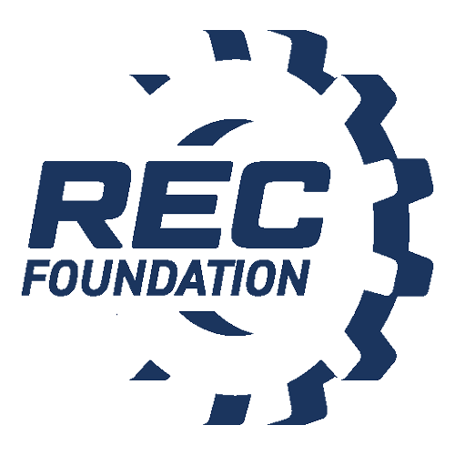

Media Contact:
NAME
PHONE
E-MAIL

[INSERT SCHOOL NAME] STUDENTS TAKE TOP HONORS AT THE [LOCAL/STATE/REGIONAL] VEX ROBOTICS COMPETITION

Local Team Aims to Contend for/Secure a Spot at the REC Foundation’s VEX Robotics World Championship

City, State – Month Day, Year – [Insert school name]’s students from [insert team name] VEX Robotics team [insert team number], secured [insert overall placement/ranking or awards received] at the VEX Robotics Competition that took place in [insert city] this past weekend. Students competed with and against [insert number of teams] teams from [insert cities or states]. The action-packed day required middle and high school students to execute the 2022-2023 VEX Robotics Competition game, Spin Up presented by the Robotics Education & Competition (REC) Foundation.

As [Insert award(s) won] recipients, the team has qualified for [Insert name of state championship or regional event], extending their journey as they seek to qualify and compete in the VEX Robotics World Championship.

[Insert school name]’s VEX Robotics Competition team is comprised of [insert team member names and corresponding ages]. To prepare for the tournament, the group worked together to design, build and program a robot using VEX V5, that could quickly and efficiently solve specific challenges that come with playing the 2022-2023 VEX Robotics Competition game, Spin Up.

Each week, the students apply what they’ve learned about STEM in the classroom, to build these semi-autonomous machines. An equally important set of skills is learned through the competition -- communication, project management, time management, and teamwork.

[Insert advisor name], the team’s advisor said, [Insert reflection on what the team/students have accomplished.]
Example: “I am proud of these students for their ability to take what they’ve learned in the classroom and apply it to building and programming a competition robot from ideation to completion. It’s been remarkable to see what they’ve accomplished in just one year and inspiring to think about the positive impact they will have on the world around them.”

[Insert school name] VEX Robotics Competition team meets [insert if they meet in the classroom] and after school [insert number of days] per week. The students learn about electronics, programming, mechanical systems, animation, 3D CAD, computer-aided machining, web design, and materials fabrication.

Team captain [insert student name] said [she/he] was proud of her peer's perseverance and accomplishments. "Our main goal was to [insert team’s strategy used to defeat other teams]. Many of the team members plan to go on to college and major in robotics, computer programming, or an engineering-related field, utilizing the skills they acquired on our robotics team.” [If the captain is a senior, or if there are any other seniors on the team, insert specifics about where they would like to attend college and what they plan to study as their major].

[Insert school names] also participated in this past weekend’s event. While [insert winning school] won the event overall, many other teams received esteemed awards. Award-winners included [insert list of award winners].

The Robotics Education & Competition (REC) Foundation manages the VEX Robotics Competition, which thousands of schools participate in around the world each year. Dan Mantz, CEO of the REC Foundation, said, “As an experienced robotics mentor, I’ve seen firsthand the engineering skill and leadership expertise that students gain by participating in the VEX Robotics Competition. It’s an experience that will stay with them long after their school days are over, offering a new appreciation for STEM and laying a strong foundation of critical problem-solving, communication, and teamwork skills that will serve them well throughout their lives.”

[Insert team name] will be competing in the upcoming [insert competition name] VEX Robotics Competition on [insert month, day, year] at [insert venue name]. The event is open and free for media, families, and other community members to attend.

The [insert competition name] is one of a series of VEX Robotics Competitions taking place internationally throughout the year. VEX Competitions are recognized as the largest and fastest-growing competitive robotics programs for elementary schools, middle schools, high schools, and college-aged students around the world. There are more than 23,000 VEX teams from 58 countries that participate in over 2,300 events worldwide. The competition season culminates each spring, with VEX Robotics World Championship, a highly anticipated event that unites top qualifying teams from local, state, regional, and international VEX Robotics Competitions to crown World Champions. More information about the VEX Robotics Competition is available at roboticseducation.org.

About the Robotics Education & Competition (REC) Foundation
The Robotics Education & Competition (REC) Foundation’s mission is to increase student interest and involvement in science, technology, engineering, and mathematics (STEM) by engaging students in hands-on, affordable, and sustainable robotics engineering programs.

# # #

