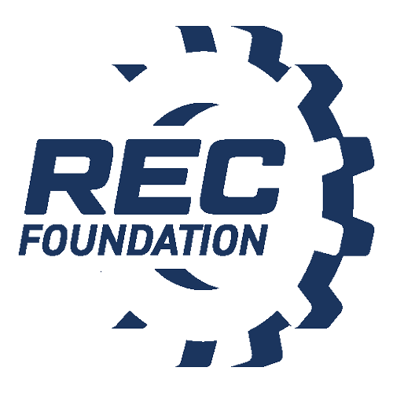

Media Contact:
NAME
PHONE
EMAIL

[INSERT SCHOOL NAME] STUDENTS TAKE TOP HONORS AT THE [INSERT EVENT NAME]

Local Team Qualifies for a Spot at the [Regional/State Championship Event Name]

CITY, State – Month Day, Year – [Insert school name]’s students from [insert team name] VEX IQ Competition team [insert team number], secured [insert overall placement/ranking or awards received] at the [insert event name] in [insert city] this past weekend. The students collaborated with [insert number of teams] teams from [insert cities or states].These/This team(s) will attempt to qualify for the chance to showcase their skills at the [insert event name].

[Insert school name]’s VEX IQ Competition team is comprised of [insert team member names and corresponding ages]. In the VEX IQ Competition, students, with guidance from their teachers and mentors, build a robot using simple, snap-together VEX IQ parts to solve an engineering challenge that is presented each year in the form of a game. Teams work together to score points in Teamwork Matches and get to show off their skills individually in driver-controlled and programming Robot Skills Challenges.

In addition to building robots, the STEM Research Project component of the VEX IQ Competition encourages students to actively explore an engineering challenge of their choice and share their research findings with event judges and their community.

The VEX IQ Competition fosters student development of teamwork, collaboration, critical thinking, project management, and communication skills required to prepare them to become the next generation of innovators and problem solvers.

[Insert advisor name], the team’s advisor said, [Insert reflection on what the team/students have accomplished.]
Example: “I am proud of these young students for their ability to take what they’ve learned in the classroom and apply it to building and programming a robot, and then going through the rigors of competing with their creation. The VEX IQ Competition has truly sparked their natural curiosity about STEM subjects, which will serve them well throughout their education.”
[Insert school name] VEX IQ Competition team meets [insert if they meet in the classroom] and after school [insert number of days] per week. They also attend [insert any relevant workshops] led by [insert who runs the workshop] from [insert affiliation] from [insert time frame of workshop] every [insert day of week].

[Insert school names] also participated in this past weekend’s event. While [insert winning school] won the event overall, many other teams received esteemed awards. Award-winners included [insert list of award winners].

“Teamwork, problem-solving, and ingenuity are all on display at a VEX IQ Competition event and students develop these skills all year long by participating on a robotics team,” said Dan Mantz, CEO of the REC Foundation. “Together, with the support of educators, coaches, and mentors, we’re fostering students’ passion for STEM at a young age to ensure that we have a generation that is dedicated to creating new discoveries and tackling life’s future challenges.”

The REC Foundation manages the VEX IQ Competition that many schools participate in around the world. VEX Competitions make up the world’s largest and fastest-growing competitive robotics programs for elementary schools, middle schools, high schools, and colleges around the world. There are more than 23,000 VEX teams from 58 countries that participate in over 2,300 events worldwide.

More information about the VEX Robotics Competition is available at roboticseducation.org.

About the Robotics Education & Competition (REC) Foundation
The Robotics Education & Competition (REC) Foundation’s mission is to increase student interest and involvement in science, technology, engineering, and mathematics (STEM) by engaging students in hands-on, affordable, and sustainable robotics engineering programs.

# # #

