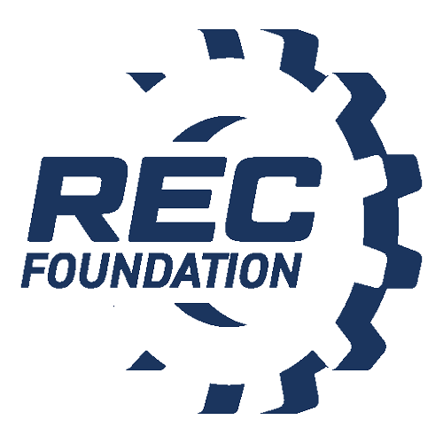

Media Contact:
NAME
PHONE
EMAIL

TEAMS SQUARE OFF AT VEX ROBOTICS COMPETITION IN
[INSERT CITY, STATE]

WHAT:
Middle and high school students from [insert team hometowns] will descend upon [insert venue location] on [insert competition date] for the 2022-2023 VEX Robotics Competition game, Spin Up, presented by the Robotics Education & Competition (REC) Foundation [insert approximate number of teams] will come together for a non-stop, action-packed day of competition where they will battle against each other with robots they designed, built and programming from VEX V5.

This tournament is one in a series of events supported by the Robotics Education & Competition Foundation. The competition season culminates each spring, with the top-performing teams from the state levels competing against each other at the VEX Robotics World Championship. At the REC Foundation’s VEX Robotics World Championship, these exemplary teams will have the opportunity to challenge their top-ranked peers from over 60 countries around the world. To learn more visit roboticseducation.org.

COMPETING SCHOOLS: [insert list of competing schools: SCHOOL NAME, CITY format]

INTERVIEW/PHOTO OPPORTUNITY: 1:1 interviews with students, event organizers, and local sponsors will be available throughout the competition. Photos of student-built VEX robots and teams interacting with their custom robots will be available upon request.

WHERE: [insert event location address]
WHEN: [insert competition schedule; example provided below]
[Date]
8:00 a.m. – 3:00 p.m. – Practice Rounds/Skills Challenges
4:00 p.m. to 6:00 p.m. – Qualifying Rounds/Finals

CONTACT:
NAME [TEAM MENTOR]
PHONE
EMAIL

NAME [SECONDARY CONTACT
PHONE
EMAIL

