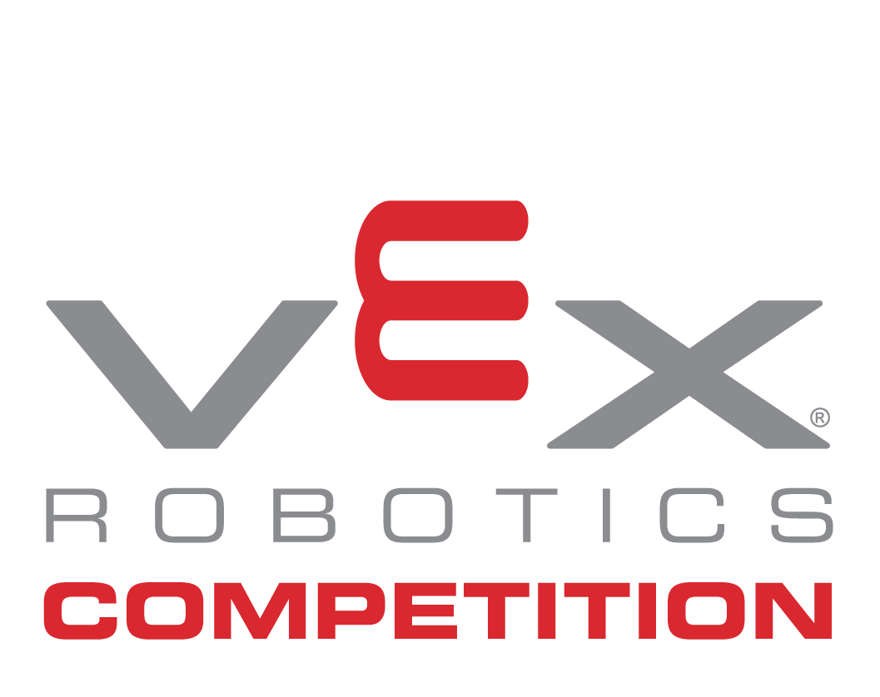
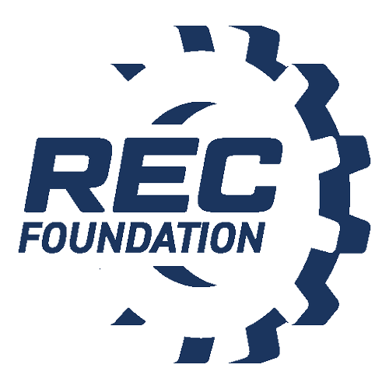

Media Contact
NAME:
PHONE:
EMAIL:

YOUNG INNOVATORS GEAR UP FOR LOCAL VEX ROBOTICS COMPETITION IN [INSERT CITY LOCATION]

Students Showcase STEM Skills with Custom-Built Robots at the [insert event name]

CITY, State – Month Day, Year – More than [insert number of participants] middle and high school students and mentors from around [insert team hometowns] will unite at the [insert venue location] on [insert event date for the 2022-2023 VEX Robotics Competition game, Spin Up, presented by the Robotics Education & Competition (REC) Foundation. The action-packed event will feature more than [insert number of teams] teams who will collaborate with other schools in a series of back-to-back robot challenges, made possible by the following sponsors: [insert sponsors]. Participants strive to succeed by strategically executing the game with robots they designed, built, and programmed using VEX V5.

This competition is one in a series of events taking place throughout the year. VEX Competitions represent the world’s largest and fastest-growing competitive robotics programs for elementary schools, middle schools, high schools, and colleges. There are more than 23,000 VEX teams from 58 countries that participate in over 2,300 events worldwide. The competition season culminates each spring with the VEX Robotics World Championship, a highly-anticipated event that unites top qualifying teams from local, state, regional, and international events who strive to secure the title of World Champions.

“Watching these innovative students design and build a robot from simple design renderings to being on the competition field is extraordinary. The opportunity for the students to compete with their peers and learn from each other is truly inspiring. The season and this event help prepare students with the skills they need to become tomorrow’s leading problem solvers and innovators,” said [insert spokesperson], [insert title] of [insert company/affiliation]. Note: Customize the quote as you’d like.

The VEX Robotics Competition serves as a vehicle for students to develop critical life skills, such as teamwork, ingenuity, and project management. These skills are honed through building robots and collaborating with like-minded students from the community.

More information is available at roboticseducation.org.

About the Robotics Education & Competition (REC) Foundation
The Robotics Education & Competition (REC) Foundation’s mission is to increase student interest and involvement in science, technology, engineering, and mathematics (STEM) by engaging students in hands-on, affordable, and sustainable robotics engineering programs.

# # #

