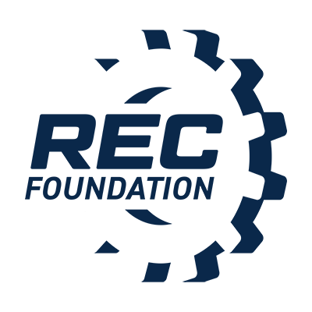
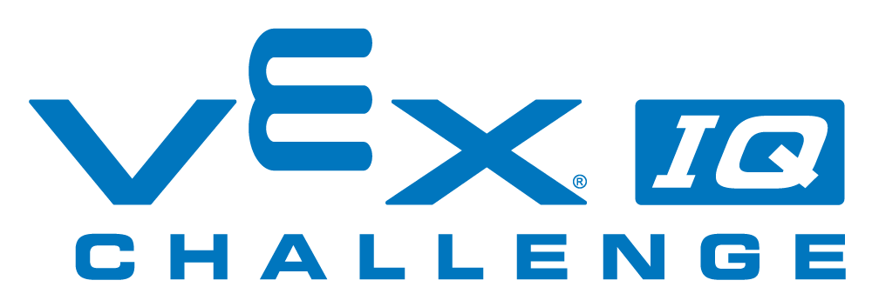
Contact:

NAME

PHONE
E-MAIL
YOUNG INVENTORS GEAR UP FOR LOCAL VEX IQ CHALLENGE IN [INSERT CITY LOCATION]
Students Showcase STEM Skills with Custom-Built Robots at the [insert event name]
CITY, State – Month Day, Year – More than [insert number of participants] elementary and middle school VEX IQ Challenge students and mentors from around [insert team hometowns] will unite at the [insert venue location] on [insert event date] for the VEX IQ Challenge Squared Away tournament. The action-packed event will feature more than [insert number of teams] teams who will collaborate with other schools in a series of back-to-back robot challenges, made possible by the following sponsors: [insert sponsors]. Participants strive succeed by strategically executing the game VEX IQ Challenge Squared Away, with robots they designed, built, and programmed using VEX IQ.
VEX IQ Challenge Squared Away is one in a series of events taking place throughout the year. VEX Competitions represent the world’s largest and fastest growing competitive robotics programs for elementary schools, middle schools, high schools, and colleges. There are more than 23,000 VEX teams from over 61 countries that participate in over 2,500 events worldwide. The competition season culminates each spring, with the VEX Robotics World Championship, a highly-anticipated event that unites top qualifying teams from local, state, regional and international VEX IQ Challenge events who strive to secure the title of World Champions.
“Watching students experience the joy of bringing a robot from simple design renderings to the competition field is quite an amazing feat. To do so in such a short span of time, with the ability to meet up at a VEX IQ Challenge event to compete with your peers and learn from each other is truly inspiring. It’s clear this event will prepare students with the skills they need to become tomorrow’s leading innovators,” said [insert spokesperson], [insert title] of [insert company/affiliation].
The VEX IQ Challenge, presented by the Robotics Education & Competition Foundation, serves as a vehicle for students to develop critical life skills, such as teamwork, ingenuity and project management. These skills are honed through building robots and collaborating with like-minded students from the community.
More information about the VEX IQ Challenge is available at RoboticsEducation.org or at RobotEvents.com and VEXRobotics.com.

About the Robotics Education & Competition Foundation
The REC Foundation seeks to increase student interest and involvement in science, technology, engineering, and mathematics (STEM) by engaging students in hands-on, sustainable and affordable curriculum-based robotics engineering programs across the U.S. and internationally. Its goal is to provide these programs with services, solutions, and a community that allows them to flourish in a way that fosters the technical and interpersonal skills necessary for students to succeed in the 21st Century. The REC Foundation develops partnerships with K-12 education, higher education, government, industry, and the non-profit community to achieve this work so that one day these programs will become accessible to all students and all schools in all communities. For more information on REC Foundation, visit www.RoboticsEducation.org.
# # #

